

**CAPSTONE PROJECT REPORT**

**Report 6 – Software User Guides**

– Hanoi, August 2019 –

**Table of Contents**

I. Project Report 3

1. Status Report 3

2. Team Involvements 3

3. Issues/Suggestions 3

II. Release Package & User Guides 4

1. Deliverable Package 4

1.1 Source codes & documents 4

1.2 Known Issues, Limitations & Restrictions 4

2. Installation Guides 4

2.1 System Requirements 4

2.2 Setup Files 4

2.3 Installation Instruction 4

3. User Manual 4

3.1 Terms and definitions 4

3.2 System requirements 4

3.3 Application Usage 5

3.4 Troubleshooting 5

# I. Project Report

## 1. Status Report

|  |  |  |  |
| --- | --- | --- | --- |
| **#** | **Work Item** | **Status** | **Notes (Work Item in Details)** |
| 1 |  | Pending |  |
| 2 |  | In Progress |  |
| 3 |  | Completed |  |

## 2. Team Involvements

|  |  |  |  |
| --- | --- | --- | --- |
| **#** | **Task** | **Member** | **Notes (Task Details, etc.)** |
| 1 |  | KienNT |  |
| 2 |  | TuanTV |  |
| 3 |  | AnhLM |  |

## 3. Issues/Suggestions

|  |  |  |  |
| --- | --- | --- | --- |
| **#** | **Issue** | **Status** | **Notes (Solution, Suggestion, etc.)** |
| 1 |  | Pending |  |
| 2 |  | In Progress |  |
| 3 |  | Completed |  |

# II. Release Package & User Guides

## 1. Deliverable Package

### 1.1 Source codes & documents

|  |  |  |  |  |
| --- | --- | --- | --- | --- |
| **No.** | **Items** | **Sub-Items** | **Type** | **Version** |
| ***Code Package*** | | | | |
| 1 | Back-end API | vn-master-api | New | 1.0.0 |
| 2 | Mobile App | vn-master-mobile | New | 1.0.0 |
| ***Database*** | | | | |
| 1 | Tables | Answer.sql | New | 1.0.0 |
| Comment.sql | New | 1.0.0 |
| Conversation.sql | New | 1.0.0 |
| History.sql | New | 1.0.0 |
| Lesson.sql | New | 1.0.0 |
| Lesson_Vocabulary.sql | New | 1.0.0 |
| Level.sql | New | 1.0.0 |
| Notification.sql | New | 1.0.0 |
| Optionq.sql | New | 1.0.0 |
| Post.sql | New | 1.0.0 |
| Progress.sql | New | 1.0.0 |
| Question.sql | New | 1.0.0 |
| Question_Type.sql | New | 1.0.0 |
| Quiz.sql | New | 1.0.0 |
| Role.sql | New | 1.0.0 |
| Unauthorized.sql | New | 1.0.0 |
| Vocabulary.sql | New | 1.0.0 |
| ***Documents*** | | | | |
| 1 | Introduction | Report1 | New | 1.0 |
| 2 | Deployment | Report2 | New | 1.0 |
| 3 |  | Report3 | New | 1.0 |
| 4 |  | Report4 | New | 1.0 |
| 5 |  | Report5 | New | 1.0 |
| 6 |  | Report6 | New | 1.0 |
| 7 |  | Report7 | New | 1.0 |

### 1.2 Known Issues, Limitations & Restrictions

## 2. Installation Guides

### 2.1 System Requirements

* For Android devices: Requires Android 5.0 and up

|  |  |
| --- | --- |
| **Operating system** | Android 5.0 or higher |
| **Processor** | 64-bit CPU with at least 4x Arm® cores (6x or more Arm cores recommended) |
| **Storage** | At least 500mb disk space to install |
| **RAM** | 1.5 GB of RAM or higher |
| **Browser/Internet** | This application requires internet connection to use |

* For Ios devices: Required at least iOS 9.0

|  |  |
| --- | --- |
| **Operating system** | iOS 9.0 or higher |
| **Processor** | Required at least Apple A6 |
| **Storage** | At least 500mb disk space to install |
| **RAM** | 1 GB of RAM or higher |
| **Browser/Internet** | This application requires internet connection to use |

### 2.2 Setup Files

* Android: vnmaster.apk
* Ios: vnmaster.ipa

### 2.3 Installation Instruction

* For Android device:

1. Press “Install” button to install the app
2. Wait for the app to install
3. Press “VN Master” with icon to start the app

* For IOS device:

1. Press “Install” button to install the app
2. Wait for the app to install
3. Press “VN Master” with icon to start the app

## 3. User Manual

### 3.1 Terms and definitions

### 3.2 System requirements

* For Android device:

|  |  |
| --- | --- |
| **Operating system** | Android 5.0 or higher |
| **Processor** | 64-bit CPU with at least 4x Arm® cores (6x or more Arm cores recommended) |
| **Storage** | At least 500MB disk space to install |
| **RAM** | 1.5 GB of RAM or higher |
| **Browser/Internet** | This application requires internet connection to use |

* For IOS device:

|  |  |
| --- | --- |
| **Operating system** | iOS 9.0 or higher |
| **Processor** | Required at least Apple A6 |
| **Storage** | At least 500MB disk space to install |
| **RAM** | 1 GB of RAM or higher |
| **Browser/Internet** | This application requires internet connection to use |

### 3.3 Application Usage

#### a. Overview

The application helps foreigners to access Vietnamese more easily through learning and practicing skills such as listening, speaking and writing. They can also exchange language skills with native speakers through study exchanges.

#### b. Login

* Purpose
  + Authenticate user
* Function
  + Sign in VN Master account
  + Sign in with Google
  + Sign in with Facebook
* User Interface

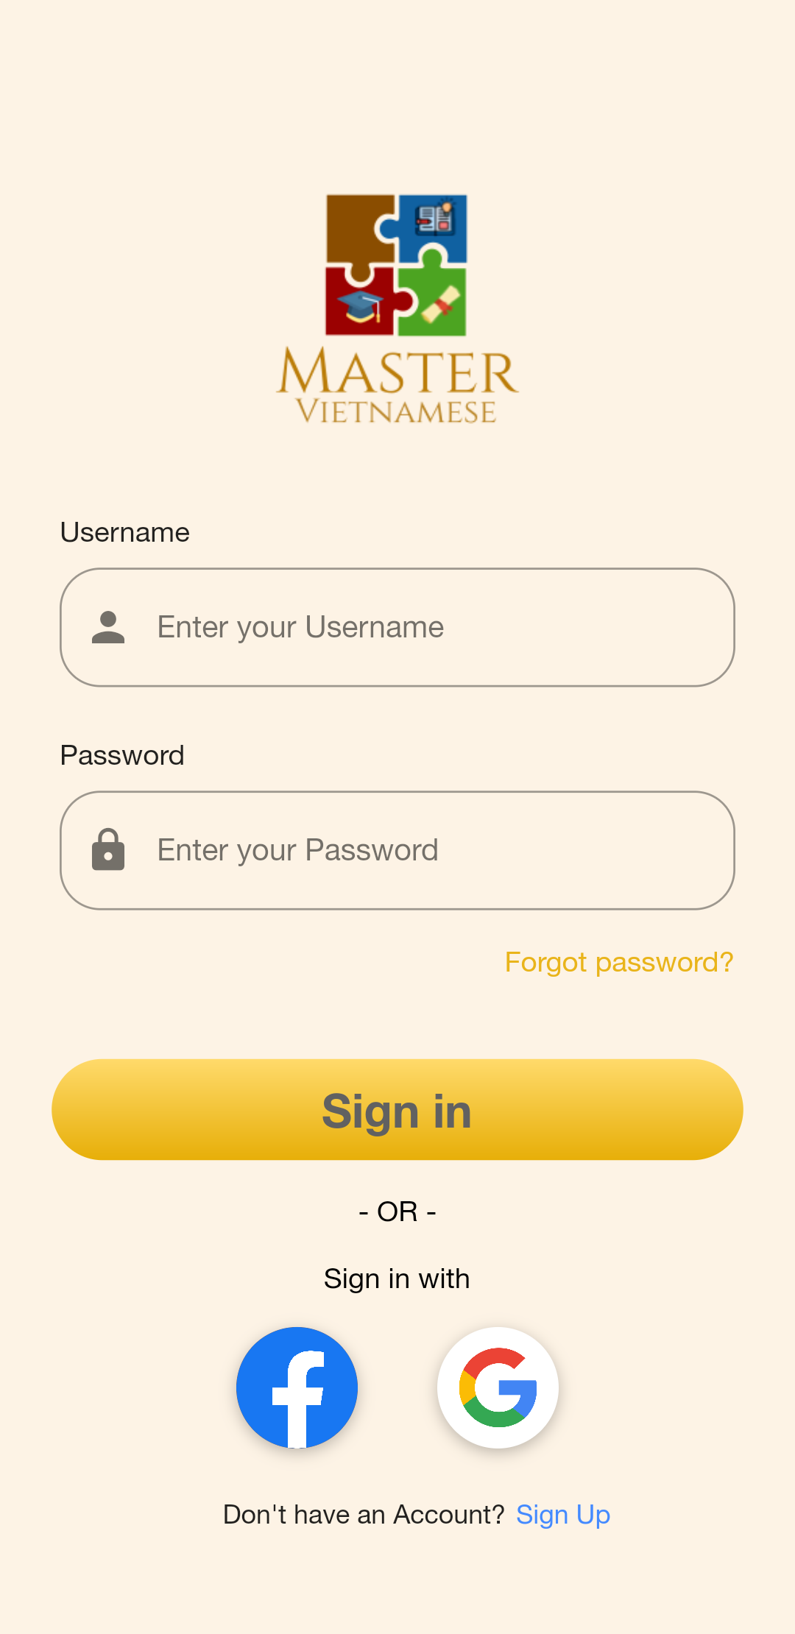

#### c. Register

* Purpose
  + Allow user to create new account
* Function
  + Create VN Master account
* User Interface

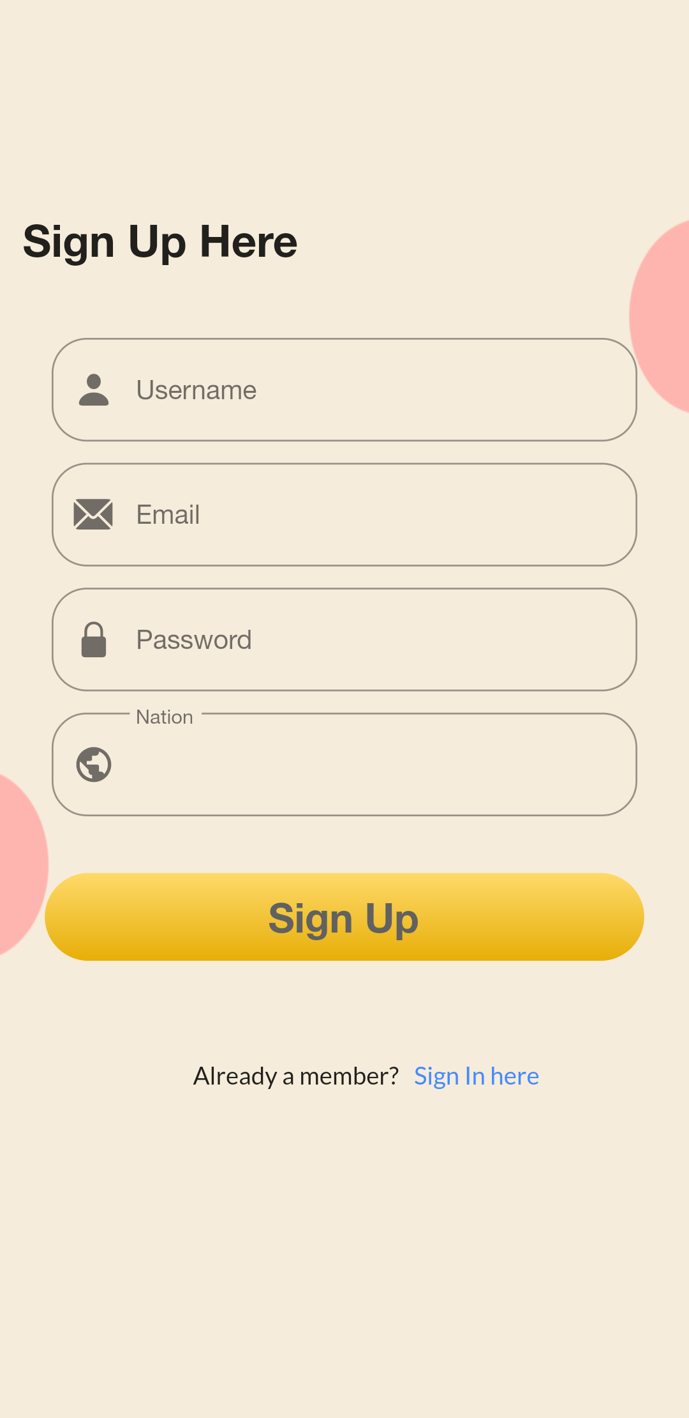

#### d. Forget password

* Purpose
  + Allow user to re-new password
* Function
  + Update password of VN Master account
* User Interface

#### e. Logout

* Purpose
  + Allow user to create new account
* Function
  + Create VN Master account
* User Interface

#### f. Choose lesson

* Purpose
  + Allow user to create new account
* Function
  + Create VN Master account
* User Interface

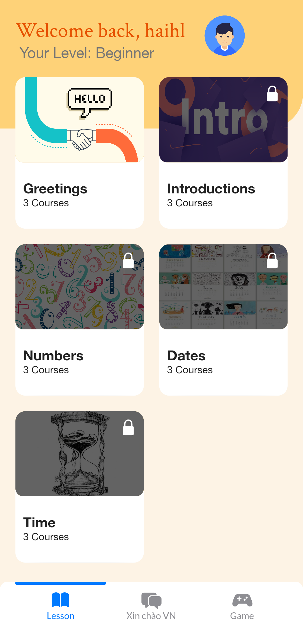

#### 

#### g. Choose Type Of Learning

* Purpose
  + Users can choose which they need to learn(Vocabulary or Conversation) or take a quiz to test their knowledge.
* Function
  + Vocabulary
  + Conversation
  + Quiz
* User Interface

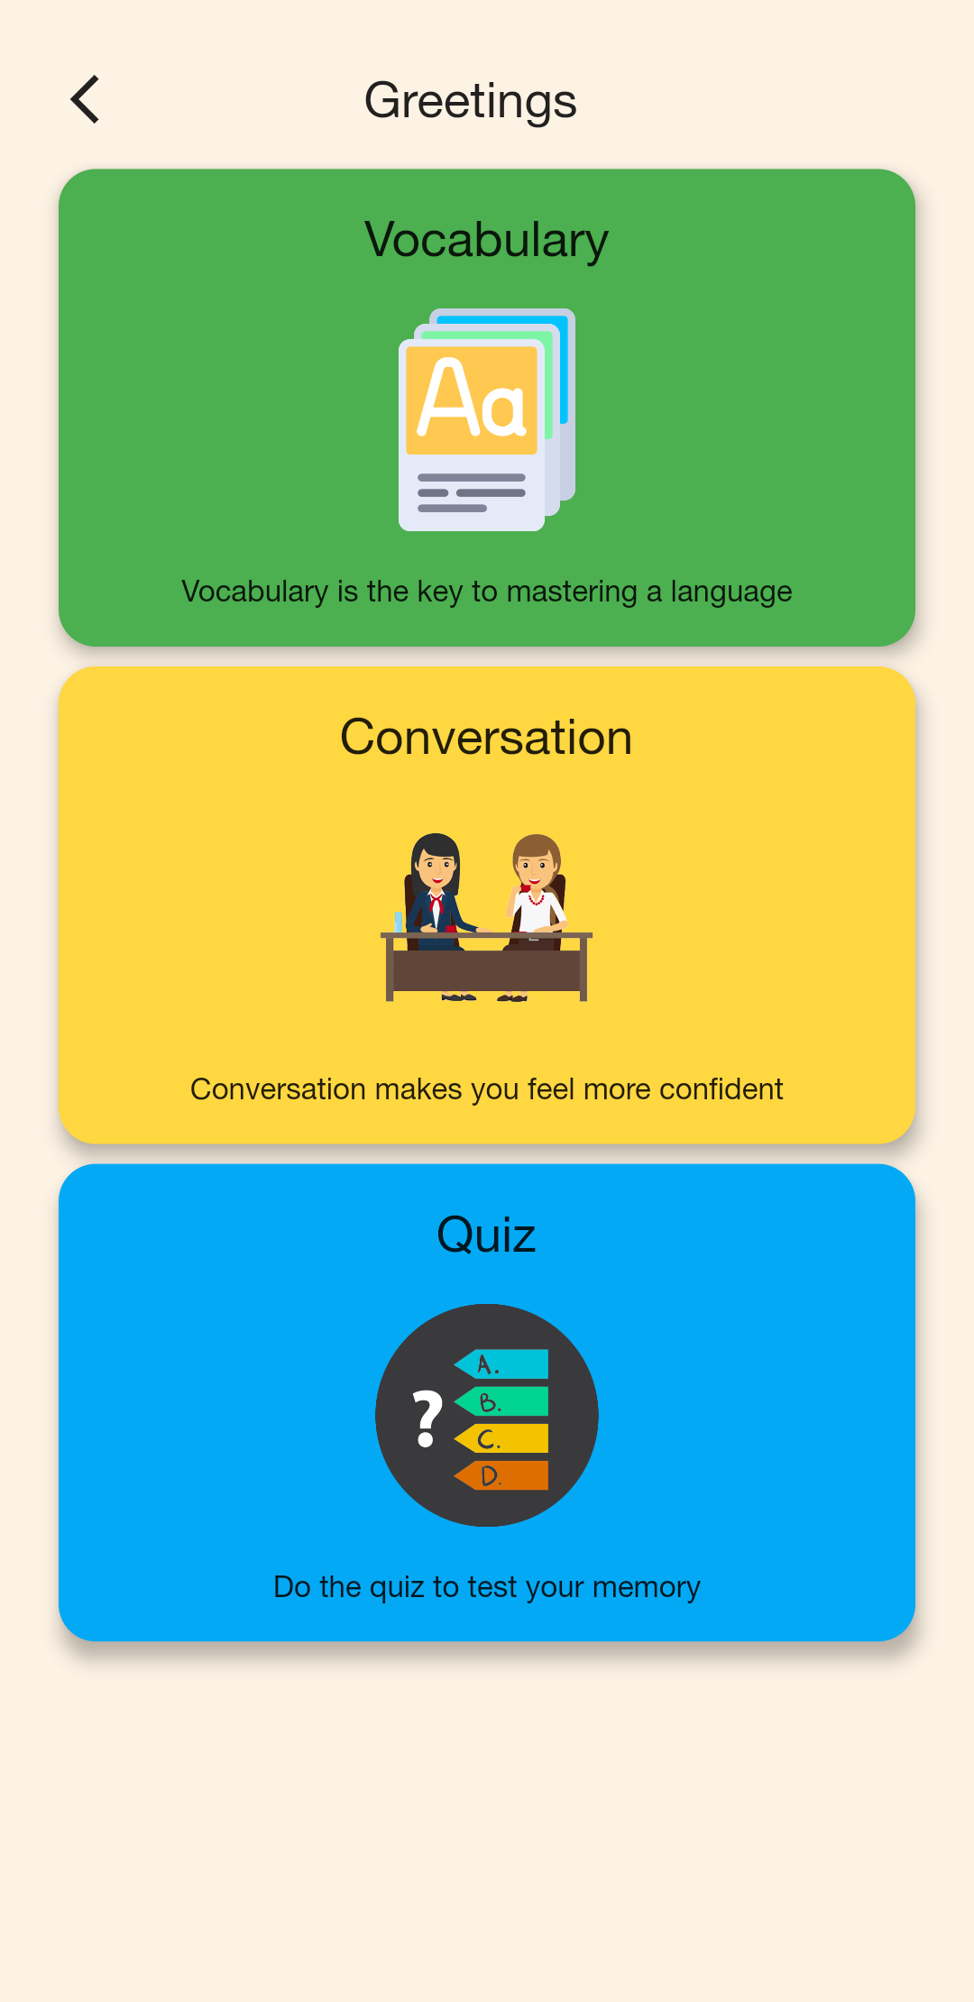

#### h. Conversation

* Purpose
  + Provide conversations that help users increase their ability to communicate
* Function
  + Overview the dialogue
  + Conversation practice
* User Interface

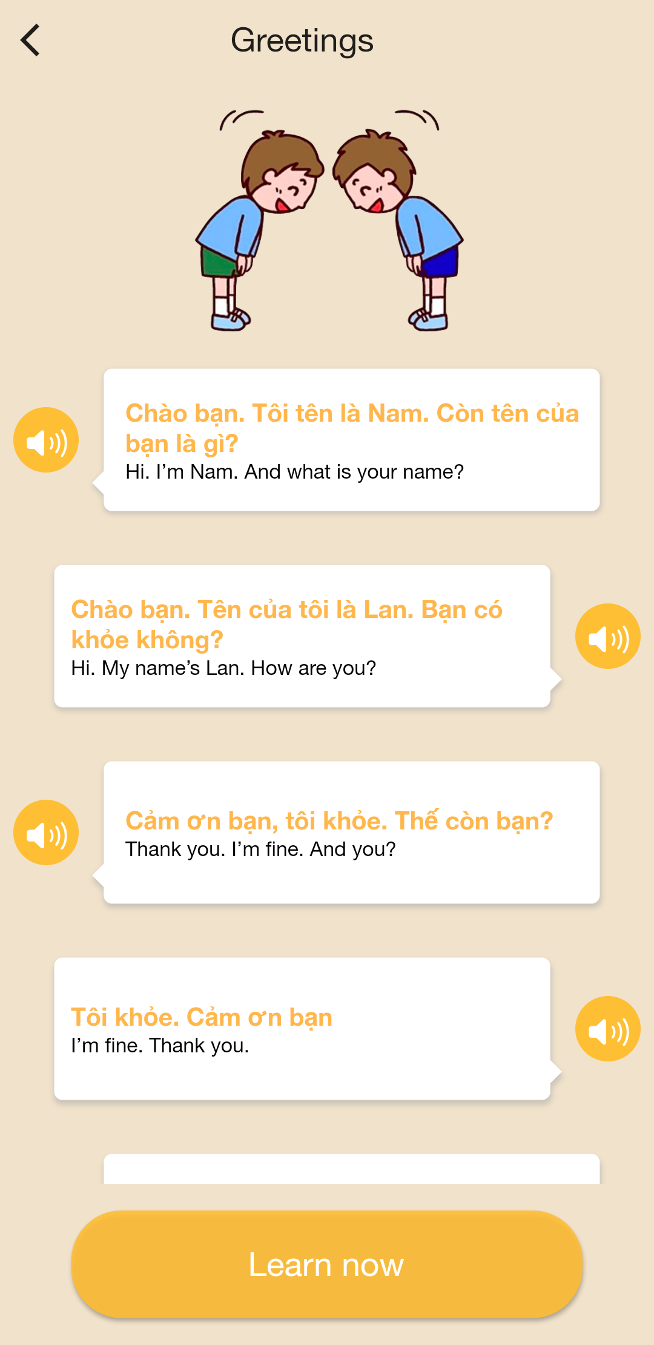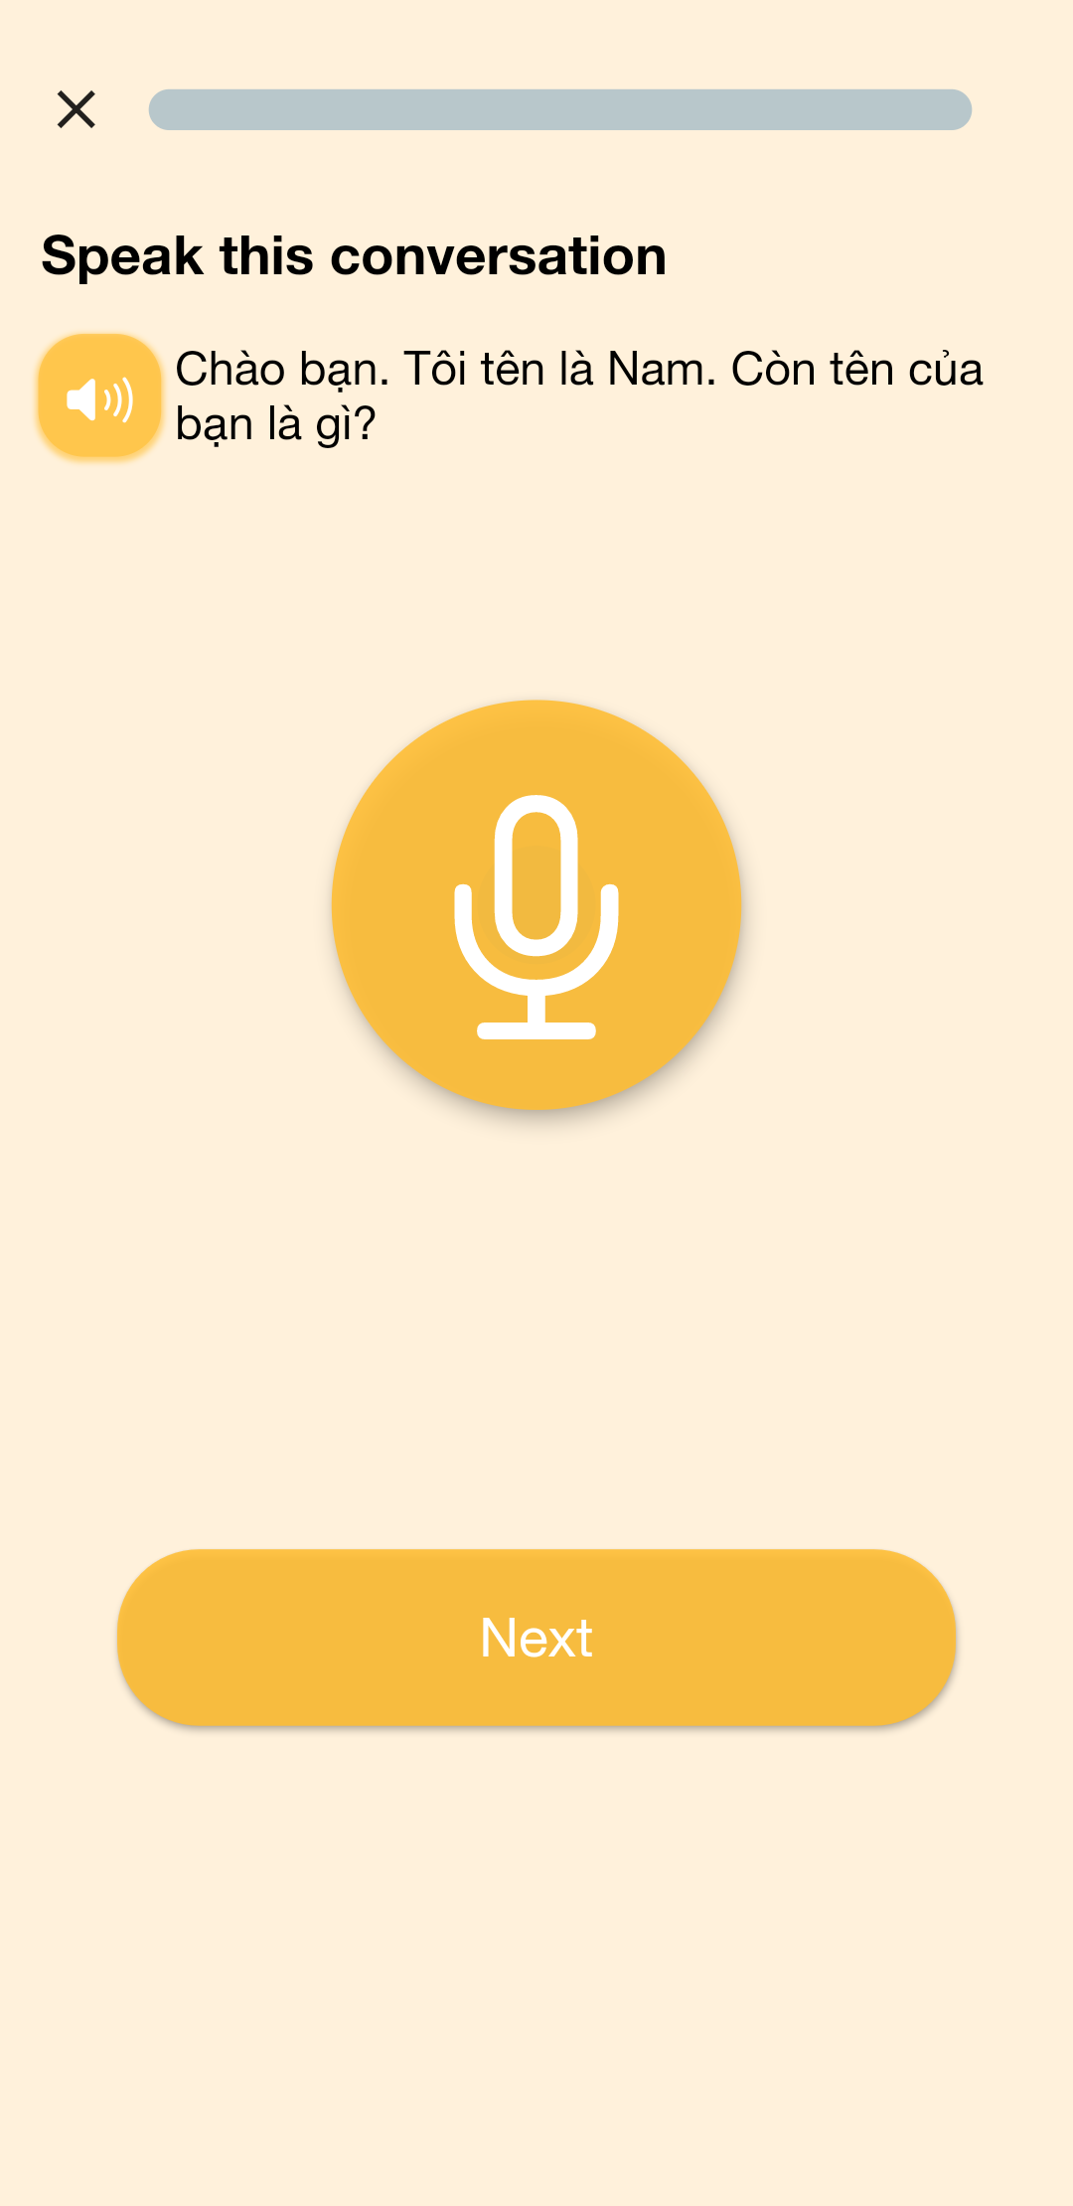

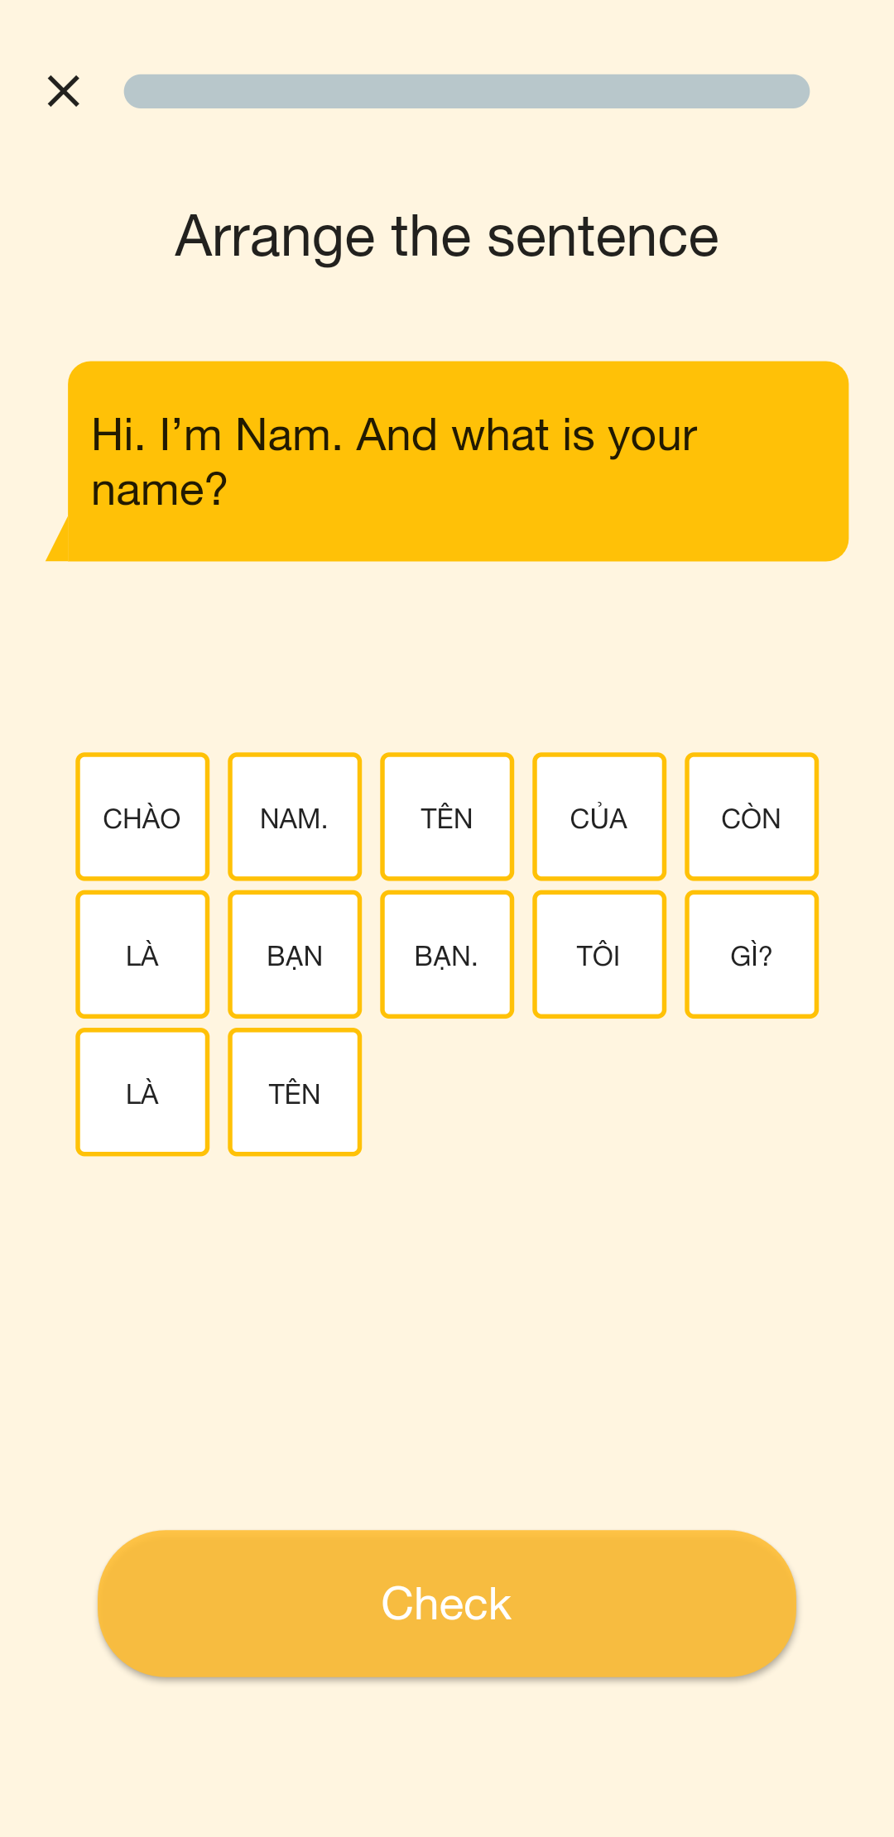

#### i. Quiz

* Purpose
  + Allow user to test their knowledge
* Function
  + Practice
  + Quiz
* User Interface

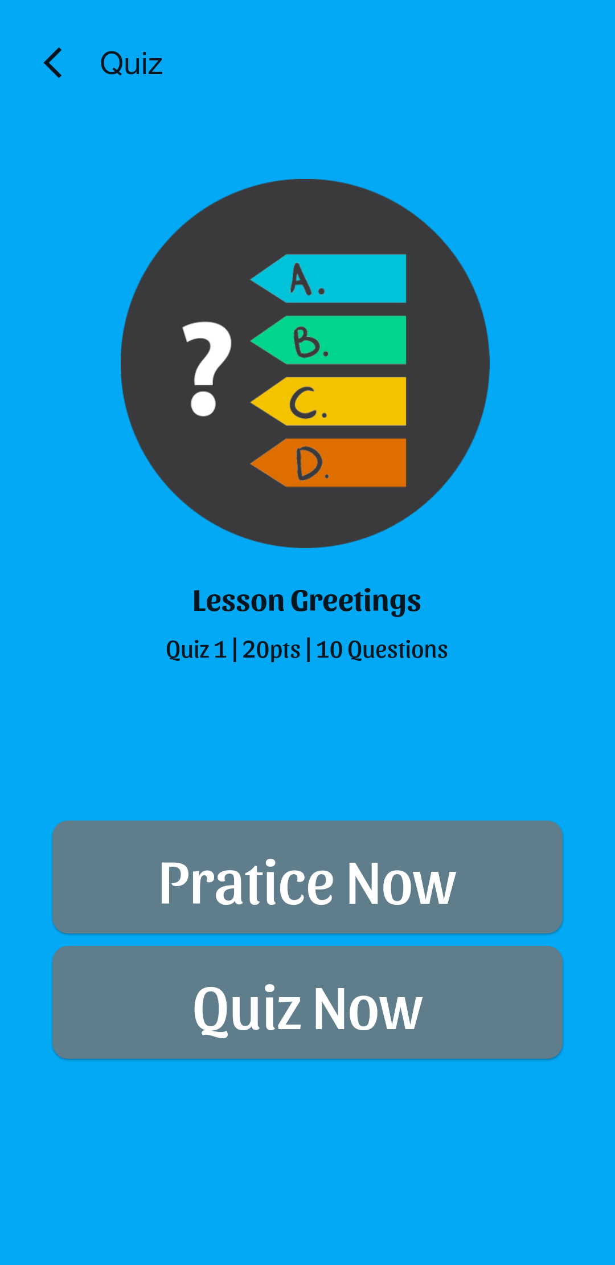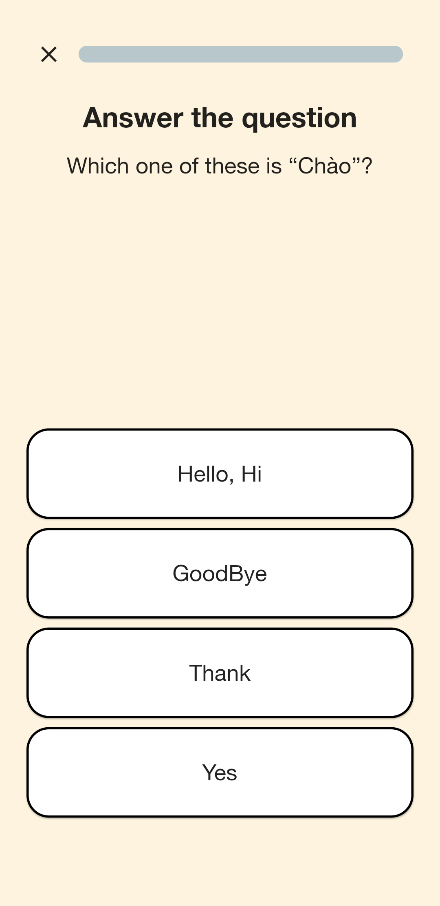

#### j. Vocabulary

* Purpose
  + Provides vocabularies to help learners improve their Vietnamese vocabulary
* Function
  + Flash card
  + Listen and write vocabulary
  + Listen and speak vocabulary
  + Arrange to correct vocabulary
* User interface

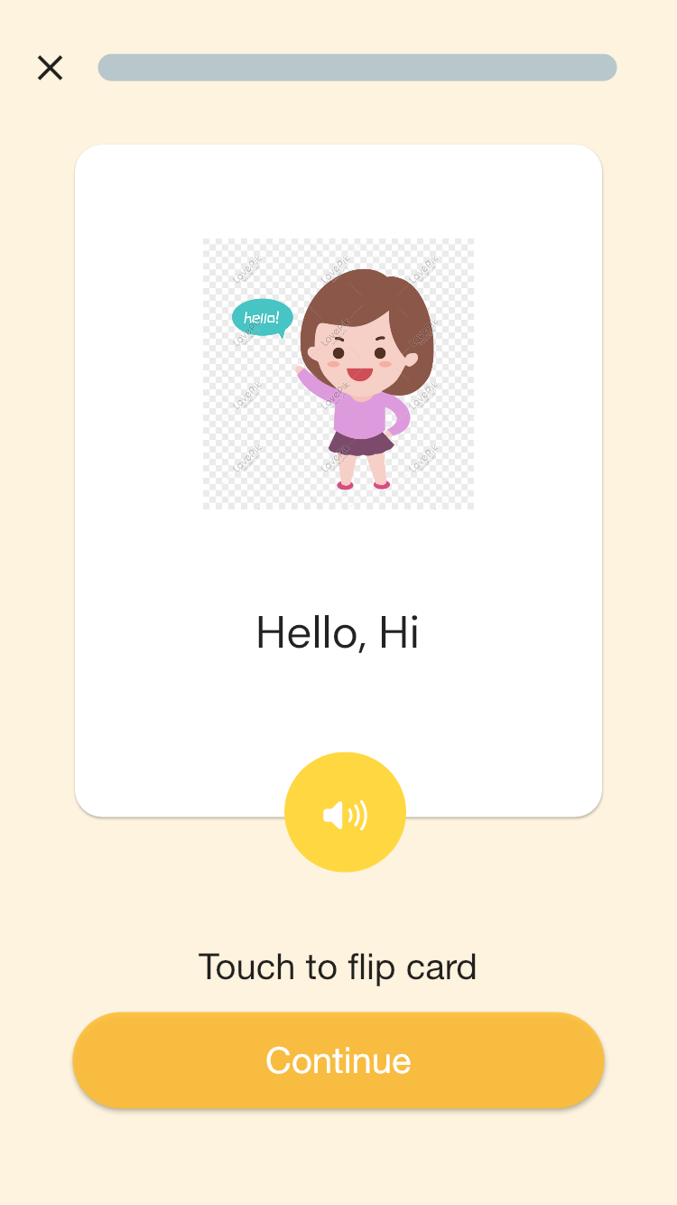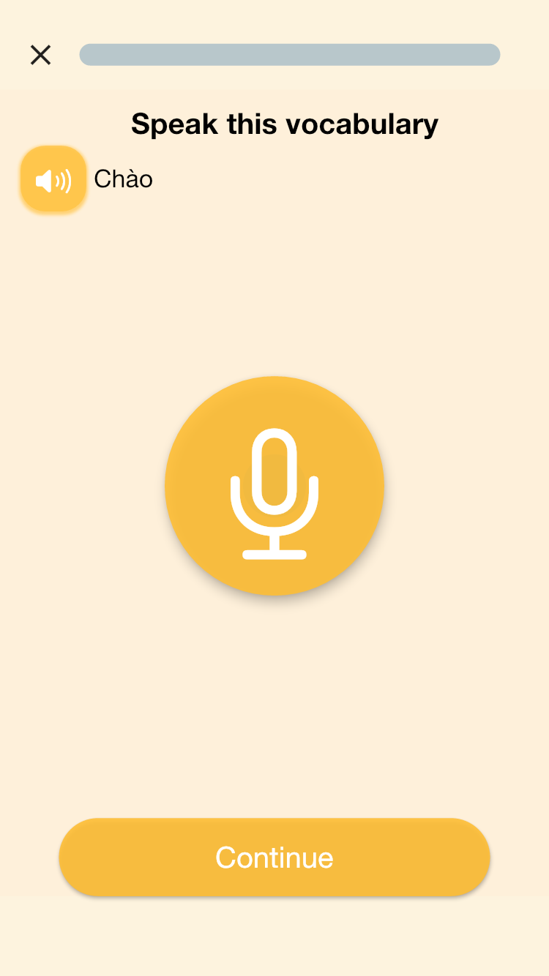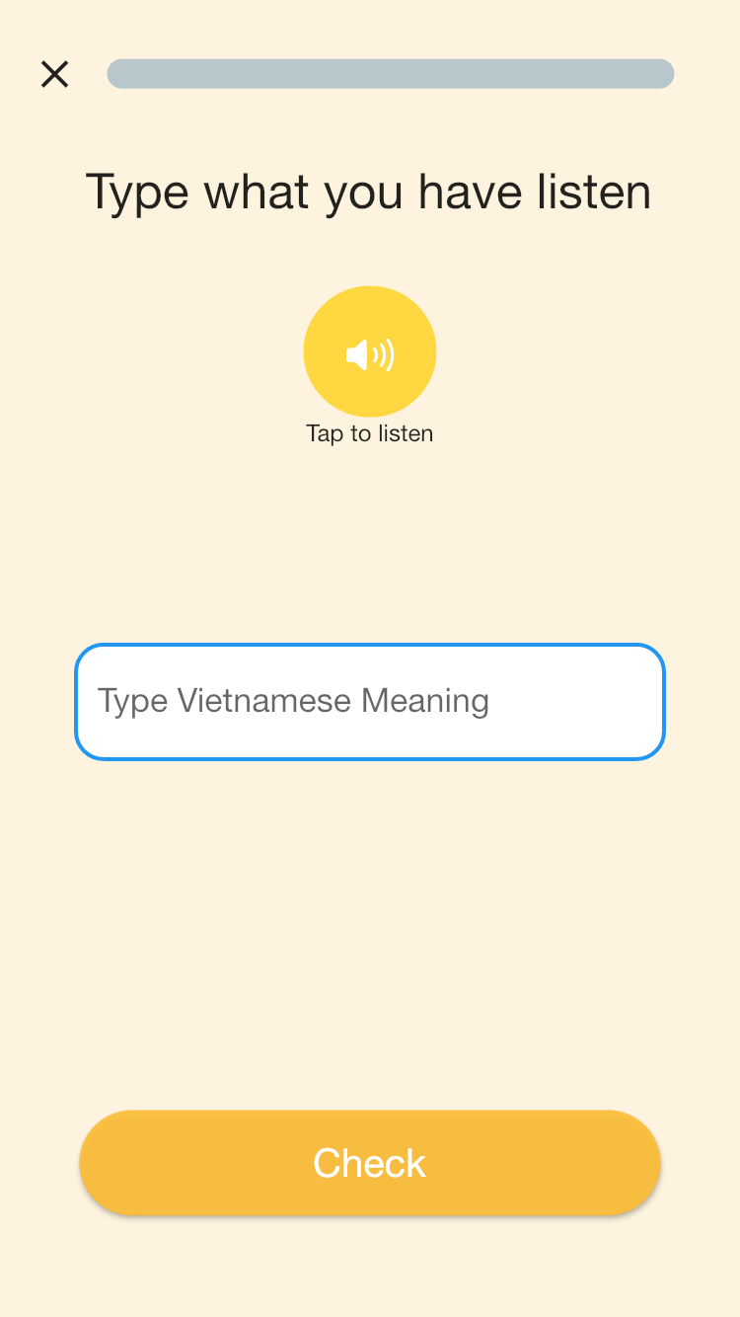

### 

### 

### 

### 

### 

### 

### 

### 

### 

### 

### 

### 

### 

### 

### 

### 

### 

### 

### 

### 

### 

### 

### 

### k. News feed

* Purpose
  + User can see all posts by time or their posts
  + User can access to search post, notification, create post screen
* Function:
  + News feed
* User interface:

### 

### 

### 

### 

### 

### 

### 

### 

### 

### 

### 

### 

### 

### 

### 

### 

### 

### 

### 

### 

### 

### 

### 

### 

### 

### l. Create post

* Purpose
  + User can create a new post
* Function:
  + Create post
* User interface:

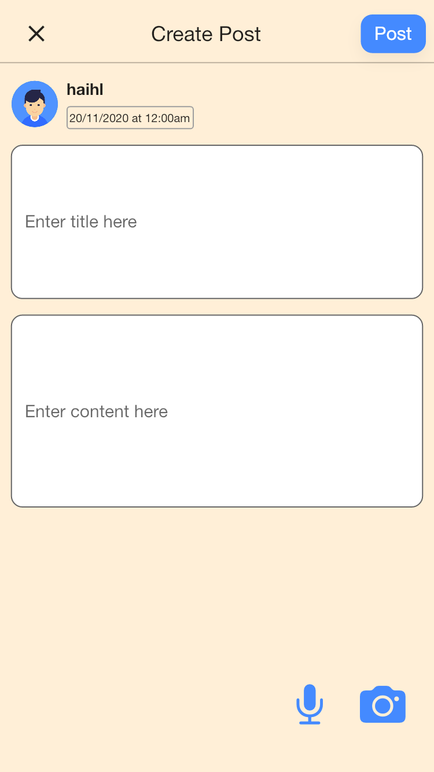

### 

### 

### m. View post details

* Purpose
  + User can view post details ( post and comments), comment post
* Function:
  + View post details, comment
* User interface:

### 

### n. Edit post

* Purpose
  + User can edit their post
* Function:
  + Edit post
* User interface:

### 

### 

### 

### 

### o. Notification Posts

* Purpose
  + User can view their notifications
* Function:
  + Notification
* User interface:

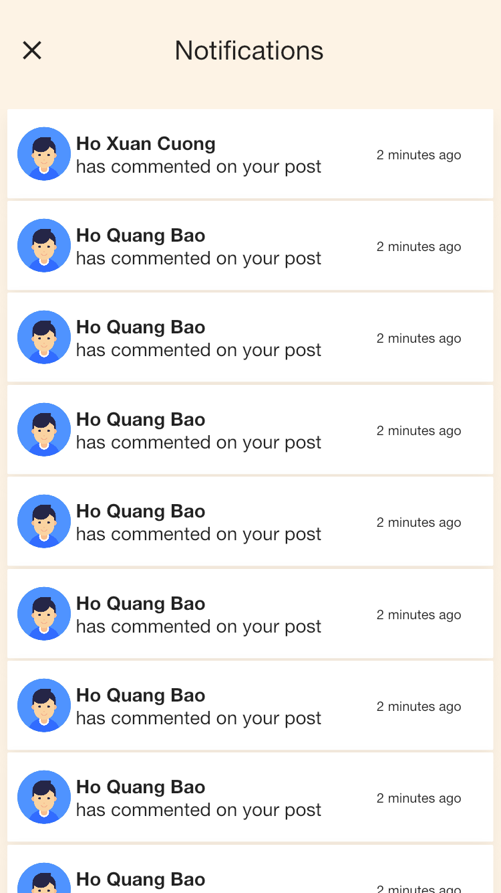

### n. Search posts

* Purpose
  + User can search post by title
* Function:
  + Search post
* User interface:

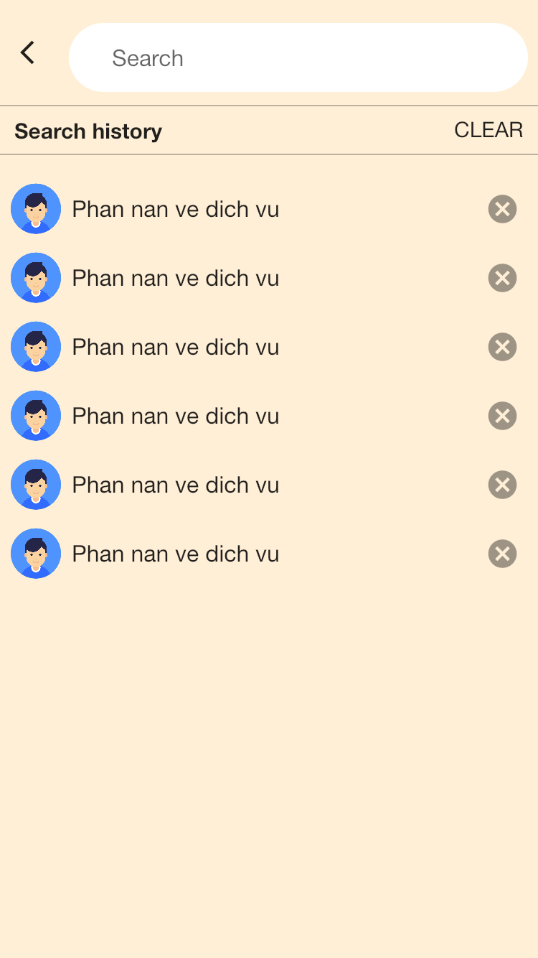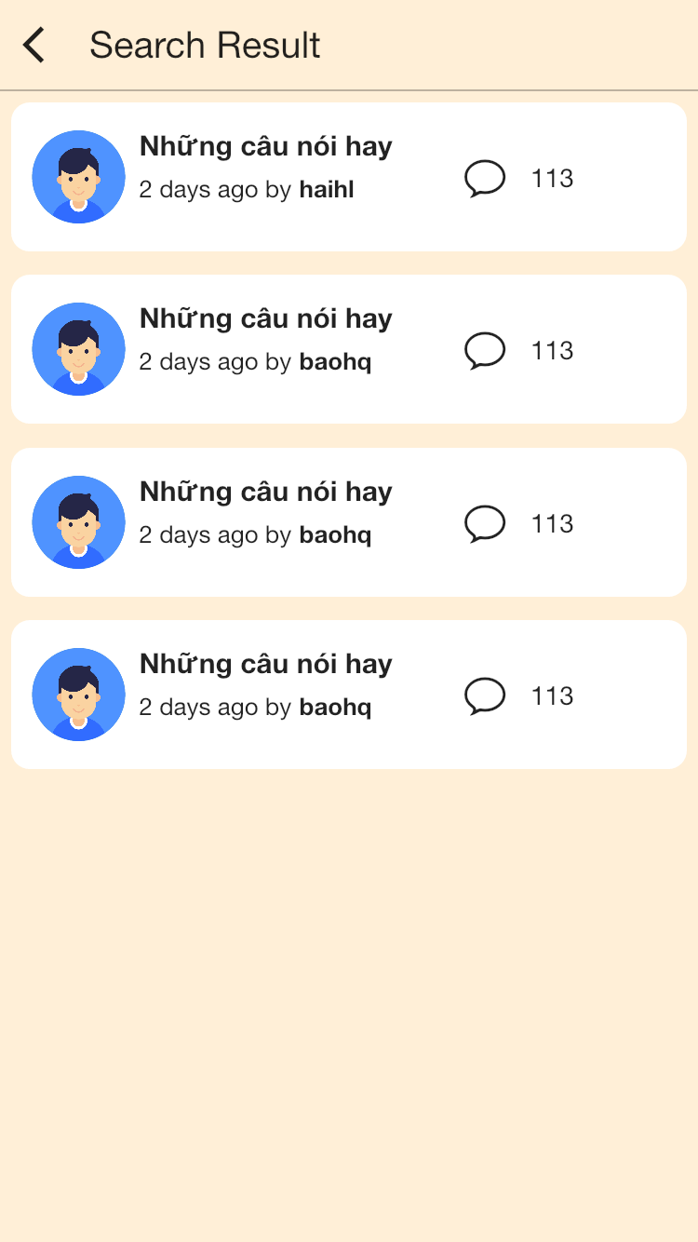

### 

### 3.4 Troubleshooting